Research option 1
Is family life fair?
If we were to rewind to the 1950s, we would see that family life used to be very unequal. Women were expected not to have a paid job, but to complete all the housework and childcare, whilst men would go out and work. Look at this page from a home economics textbook in the 1950s:
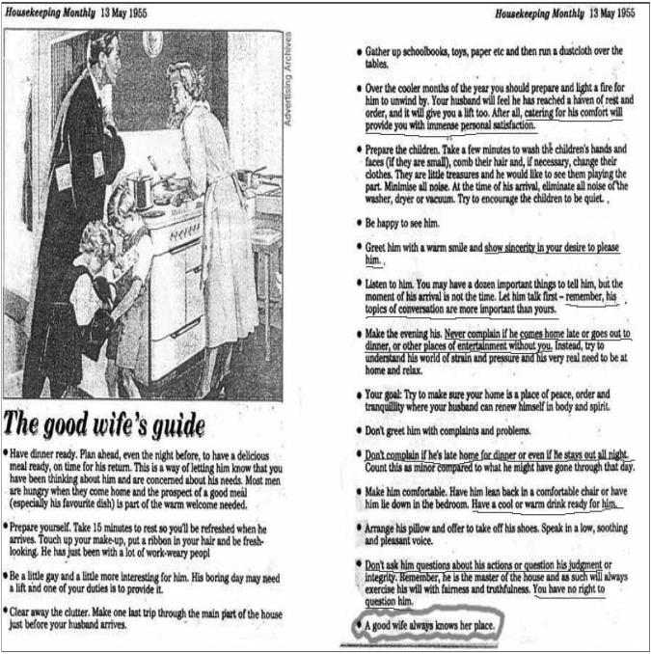

- What does this show about the role of women in the family?
- What would feminists think about this?
- How has this changed?
Today, men and women are more equal. Women are likely to have a paid job as well as men, and men and women are both likely to contribute to family life and tasks. However, there are still inequalities between men and women in the family. Men are usually paid more than women, and so have more power, and women often still complete up to 60% more housework and childcare than men.
Many women must perform the ‘double shift’ – which means doing two shifts of work, one in their paid role, and one at home. Some sociologists also argue that women perform more emotional labour – remembering birthdays, comforting people when they are upset, scheduling appointments and so on.

In your opinion, should women do more housework and childcare than men? Why/ Why not?

Research task: read/ watch/ listen to the sources below and record the key points. Then write 500 words explaining whether or not family life in the UK is fair in your opinion. Try to use evidence and examples where possible.
Source | Key points
Article: Why is there still a housework inequality gap?
Article: What is emotional labour?

Clip: Sociologist Arlie Hoschild discussing the second shift
Documentary: What stands in the way of women becoming equal to men?
Article: The ‘tradwife’ movement, encouraging young women to revert to 1950s expectations

Write your response here

Research option 2

Is the education system fair?
- Education policy institute found disadvantages children were 18 months behind their peers by the time they took their GCSEs
- More affluent (advantaged) students have heard 30 million more words than disadvantaged students by the time they are 5
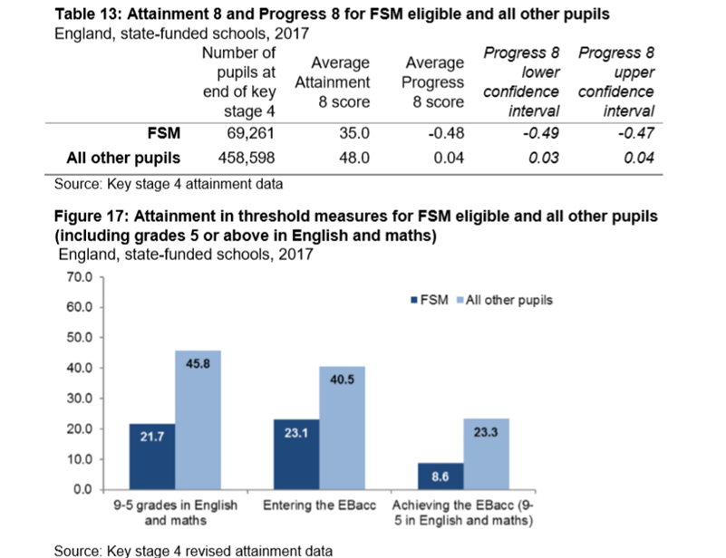
Pupils can claim Free School Meals if their household income is less than £16,000, so it is used as a measure of social class or poverty.
- What percentage more students not on FSM achieve a grade 5 in English and Maths compared to students on FSM?
- What does this show about which students do better in education?
- Can you think of any reasons for this?
At school, children from different backgrounds receive very different outcomes in education. Here are some of the main reasons:
- Material deprivation – students may lack the physical resources they need to study, like books and internet access. How might this impact their exam results?
- Labelling – students may be labelled as lower achieving by teachers. This is when teachers attach a label to students and treat them differently. They may see working class students as less motivated, less able and less hard working. How might this impact their results?
- Parental attitudes – parents from working class backgrounds may be less involved and less engaged in their children’s education, possibly because they had a bad experience of school themselves.
Many wealthy parents can afford to send their children to independent schools too.
Some sociologists also argue ethnic minorities have a worse experience of education, because they experience racism and institutional racism. Some also argue these inequalities are due to differences in the family structures of different ethnicities.
Research task: read the articles and watch the documentaries and listen to the podcast to get a better understanding of the inequalities in education. Use the information to write 500 words explaining why education in contemporary Britain may not be fair, including which groups may be more disadvantaged.
Source | Key points
Podcast: Professor Cecil Wright discussing the ethnic inequalities in education, including her experiences at school

Article: Diane Reay explaining the unequal treatment of working class children in education

Report (just read the executive summary): The impact of attitudes and expectations on educational attainment
Documentary: Too Poor for Posh School?

Clip: Should we abolish private schools?

Documentary: Professor Green, Living in Poverty

Write your response here

Research option 3
Is the criminal justice system fair?
The criminal justice system refers to all parts of the system that creates and enforces the laws. This includes the government, who create and pass laws, police officers, who enforce the laws, judges, who decide sentences for those convicted of crimes and prison and probation officers.
Here are some statistics on the criminal justice system:
- Black people are 9 times more likely to be stopped and searched by the police
- The police are 3 x more likely to use force against black people
- Young, black males are overrepresented in prison
There are many explanations for these statistics, summarised below:
- Institutional racism: this means racism embedded in the criminal justice system. The murder of Stephen Lawrence in 1993 by five white youths led to the Macpherson Report of 1998 and revealed the huge extent of institutional racism in the police force – the report recommended increasing the diversity of the police force and establishing an independent police complaints service, but there are still concerns of institutional racism in the police today.
- Family structure: Tony Sewell argues lone parent families are likely to lead to black boys being involved in crime
- Poverty: people from some ethnic minority backgrounds are more likely to live in poverty and therefore more likely to commit crime.
The treatment of different groups, particularly different ethnicities, in the criminal justice system demonstrates one of the main inequalities which remains an issue in the UK, affecting people’s life chances significantly.
This results both in it appearing that more ethnic minority groups, especially black people, commit more crime (when they may just be targeted more by the police) and ethnic minority individuals not being taken seriously as victims of crime.
In addition, feminists argue women are often not taken seriously as victims of crime like domestic violence and sexual assault. They argue the patriarchal criminal justice system are keen to blame women for making themselves into victims of these crimes by dressing/ acting a certain way.
Even though there are a specific set of laws that everyone must follow, sociologists argue that these rules and the enforcement of the law are applied differently, unequally, to different groups of people, resulting in these inequalities.

Research task: read/ watch/ listen to the sources below, and write 500 words describing whether or not the criminal justice system is fair and why/ why not.

Source | Key points
Documentary: Stephen Lawrence, Time for Justice
Article: Institutional Racism 20 years after Stephen Lawrence’s murder
BBC Teach Clip: Institutional Racism
Article: David Lammy describing why stop and search is unfair
Clip: Tony Sewell explaining his perspective that lone parent families lead to black boys being involved in gangs
Clip: David Lammy discussing racial bias in the Criminal Justice System

Write your response here

Further reading/ watching/ listening
Documentaries/ TV | - Panorama, Louis Theroux, Stacey Dooley, Mind of a Murderer etc  - I, Daniel Blake (Amazon Prime)  - Years and Years (BBC i-player)  - The ‘Up’ series (eg. 56 Up, 63 Up - on Netflix or Youtube)  - The Secret Life of 5 year olds (Channel 4 series)  - McMafia (Netflix)  - Freedom Writer’s Diary (Amazon Prime)  - When They See Us (Netflix)  - The Society (Netflix)  - Love, Simon (Amazon Prime)  - Ted Talks/Sociology (online)  - Made in Dagenham (BBC i-player)  - Wonder (Netflix)  - The Wife (Netflix)  - Growing up Gifted (iPLayer)
Links to documentaries | Poor Kids: Life on the Breadline (Child Poverty Documentary) | Real Stories  www.ted.com/talks?topics%5B%5D=sociology  BBC Panorama  www.bbc.co.uk/programmes/topics/Sociology_of_culture  Black Mirror  www.channel4.com/programmes/dispatches
Books | - Brave New World – Aldous Huxley  - Animal Farm – George Orwell  - 1984 – George Orwell  - Educated – Tara Westover  - Invisible Women – Caroline Criado Perez  - Chavs: The Demonisation of the Working Class – Owen Jones  - The Establishment and How They Get Away With It – Owen Jones  - Natives - Akala  - The Handmaid’s Tale – Margaret Atwood (also a series)  - Vox – Christina Dalcher  - The God Delusion – Richard Dawkins  - Outsiders: Studies in Sociology of Deviance – Howard S Becker  - Folk Devils and Moral Panics – Stanley Cohen  - A Glasgow Gang Observed – Patrick James  - Gang Leader For A Day – Sudhir Venkatesh
Podcasts | http://podcasts.ox.ac.uk/series/department-sociology-podcasts  https://www.spreaker.com/show/the-sociology-show  www.anchor.fm/allsociology  www.measureradio.libsyn.com/podcast  www.socialsciencespace.com/author/socialsciencebites  www.thesocialbreakdown.com  www.soundcloud.com/thesociologicalreview  www.bbc.co.uk/programmes/b006qy05  www.anchor.fm/digital-sociology-podcast
Websites | www.theguardian.com/education/sociology  www.nytimes.com/topic/subject/sociology  www.tutor2u.net/sociology/blog  www.nortonbooks.typepad.com/everydaysociology/  www.soc.washington.edu/news  www.sociologysal.blogspot.com  www.gendersociety.wordpress.com  www.creativesociology.blogspot.com  www.sociologylens.net  www.blogs.lse.ac.uk/impactofsocialsciences/  https://revisesociology.com/  https://www.senecalearning.com/  https://www.tutor2u.net/sociology  https://www.aqa.org.uk/subjects/sociology/as-and-a-level/sociology-7191-7192  https://thesociologyguy.com/a-level-sociology/  https://www.youtube.com/channel/UC6VpoZj33Df_rNb8KymCczw  https://napierpress.com/
Online courses | - Intro to Sociology (New York University): https://www.courses.com/new-york-university/intro-to-sociology  - Introductory sociology (Indian Institute of Technology, Kanpur): https://www.courses.com/indian-institute-of-technology-kanpur/introductory-sociology  - Foundations of modern social theory (Yale University): https://www.courses.com/yale-university/foundations-of-modern-social-theory  - Reading Marx’s Capital (City University, NY): https://www.courses.com/city-university-of-new-york/reading-marxs-capital  - What do we mean by ‘family’ (intermediate): https://www.open.edu/openlearn/society-politics-law/sociology/what-do-we-mean-family/content-section-0?active-tab=description-tab  - ‘Problem’ populations, ‘problem’ places (intermediate): https://www.open.edu/openlearn/society-politics-law/sociology/problem-populations-problem-places/content-section-0?active-tab=description-tab  - Children’s rights (intermediate): https://www.open.edu/openlearn/people-politics-law/politics-policy-people/sociology/childrens-rights/content-section-0?active-tab=description-tab  - Social problems – who makes them (intermediate): https://www.open.edu/openlearn/people-politics-law/politics-policy-people/sociology/social-problems-who-makes-them/content-section-0?active-tab=description-tab  - Identity in question: https://www.open.edu/openlearn/people-politics-law/politics-policy-people/sociology/identity-question/content-section-0?active-tab=description-tab  - Social construction and social constructionism (intermediate): https://www.open.edu/openlearn/people-politics-law/politics-policy-people/sociology/social-construction-and-social-constructionism/content-section-0?active-tab=description-tab  - Understanding economic inequality: https://www.open.edu/openlearn/society-politics-law/understanding-economic-inequality/content-section-0?active-tab=description-tab  - Beyond the ballot – Women’s rights and suffrage from 1866 to today: https://www.futurelearn.com/courses/womens-rights  - Understanding gender inequality: https://www.futurelearn.com/courses/understanding-gender-inequality  - Religion and conflict: https://www.futurelearn.com/courses/religion-and-conflict  - Why religion matters – religious literacy, culture and diversity: https://www.futurelearn.com/courses/why-religion-matters  - Gender representation in the media: https://www.futurelearn.com/courses/gender-and-the-media

