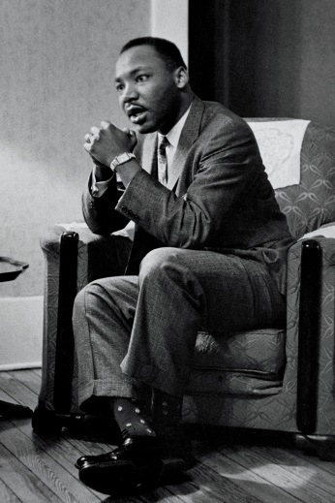
Enquiry title: “Martin Luther King made the most significant contribution to the advancement of African American civil rights.” How far do you agree with this view for the period 1863-1968?
One of the components of your A level course will be a non-examined assessment (20% of your grade). This requires you to undertake independent research into a topic of your choice. For this piece of coursework you will need to produce an extended piece of writing that analyses concepts such as change, continuity, significance, causation, diversity. You will also need to assess historians’ interpretations and analyse contemporary sources (i.e. from the time period you are investigating). Your question could focus on a key individual or a turning point event. The above question clearly focuses on the importance of the role of the individual in the gaining of African-American civil rights and requires a balanced analysis on the relative importance of individuals.

TASK 1:
“King’s career spanned less than thirteen years, but during that time, from 1956-1968, he became the most popular and effective leader of the civil rights movement in America, and emerged on the international stage as a forceful and eloquent proponent of nonviolence. Showered with awards and prizes…he still casts a long shadow…thousands of streets, schools and public buildings commemorate his memory…his name is respected throughout the world; his example is an inspiration to oppressed peoples.” Martin Luther King, Jr by Adam Fairclough (1995)
Find another historian that presents a scholarly interpretation (i.e. from an academic historian, so check their credentials – are they an expert in their field, do they lecture at a university?). Remember to reference the historian you have found. Challenge yourself – perhaps you could find an historian who argues that another individual made a more significant contribution.
TASK 2:
Find at least three contemporary sources of evidence (i.e. ones from the civil rights period such as a diary entry, newspaper report, speech, painting, contemporary novel, legal document) that shed light on the question. Explain how they have been useful in helping you to investigate the topic. Here is an example:
“Non-violent direct action enabled the Negro to take to the streets in active protest, but muzzled the guns of the oppressor because even he could not shoot down in daylight unarmed men, women and children. This is the reason why there was less loss of life in ten years in southern protest than in ten days of northern riots.” Martin Luther King, Look Magazine (1968)
TASK 3:
Research the contribution of Martin Luther King and at least one other individual and write an explanation of who you think made the bigger contribution to the advancement of African-American civil rights.
Suggested resources:
The Historical Association has a wide range of resources for students such as this one:
- https://www.history.org.uk/student/resource/9784/film-an-introduction-to-the-african-american-civi
You can also use google books and JSTOR (free to register) to find books and articles.
And websites such as these are also recommended:
- https://spartacus-educational.com/USAcivilrights.htm
- https://www.britannica.com/event/American-civil-rights-movement

