What to do today
IMPORTANT Parent or Carer – Read this page with your child and check that you are happy with what they have to do and any weblinks or use of internet.

1. Read the start of a story
- Read Ananse, the forgetful guest Part 1. This is the start of a story about Ananse. The story is from West Africa. Ananse is half-man, half-spider. What could you say about Ananse’s character?

2. Answer some questions
- Read Part 1 Questions. Think carefully about your answers.
- Write your answers as clear sentences.

3. Predict the end of the story
- What do you think could happen in the second part of the story? Will Ananse get to eat? How might that happen?
- Use Story Summary and Predictions to show your idea. Use words and pictures in the first three boxes to tell what has happened so far. Use the next three boxes to tell what you think might happen next.

Well done! Now show a grown-up your prediction for the end of the story. Can they think of a different way that it could end? You can check your answers to the Part 1 Questions at the end of this pack.

Try this Fun-Time Extras

- Can you make up a play about this part of the story? Write lines for Ananse, the king and the servants.
- Can you make an illustration for this part of the story?
- Can you write a description about what you would like to feast on if you had been journeying for days?

Ananse, the forgetful guest – Part 1

This is a West African story about Ananse. The mythical half-spider/half-man character.

Ananse had journeyed for miles and miles. Now after several days of tracking through the forest, his journey was almost at an end. Ananse could think only of one thing—food. On the nights he had spent in the forest, he had dreamed of food—hot steaming rice and spinach sauces, or crab and palm nut soup. Now he was | 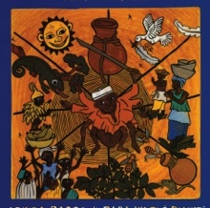
at last in the great town of Po-Ano, a guest of none other than the king of the coast lands. The king was a kind man, and after making sure that Ananse had been given a room, water to bathe and a change of clothes, he instructed his servants to prepare a meal for him. Imagine the pleasure Ananse felt as the smell of cooking food filled his nostrils.

"Let me guess," he chuckled to himself. "This will be rice and chicken stew that's cooking." Unable to wait any longer, Ananse dressed quickly and followed his nose to the kitchen.

"Ah, Mr. Ananse, you are most welcome," said the servants.
"You must be very hungry after your long journey."
"Yes, indeed," replied Ananse. "Right now, with the smell of your food filling this room, it is my pleasure to be hungry."

With a flourish, the servants lifted the lid off Ananse's bowl. But at the sight of the food, Ananse collapsed, for in the bowl was the most despised of foods—dried cassava mash. He couldn’t face eating it! He pretended to faint and the servants called for help.

By the time help arrived, Ananse had emerged from his sudden faint. "It is nothing," said Ananse weakly. "It’s just that I’m allergic,” he lied. “Cassava is forbidden to me. Even the sight of it affects me.”

“Oh, dear,” said the king. "I am afraid this is going to be a difficult visit for you. In this town we eat cassava at every meal."

Impossible, thought Ananse. This must be a trick to test me. Why would people eat cassava at every meal? But they did! In the mornings they ate cassava porridge, in the afternoons they ate cassava mash, and in the evenings they ate their cassava roasted. Ananse had to go out each day to find moist leaves and bugs to eat, for the news had spread that cassava was forbidden to him.

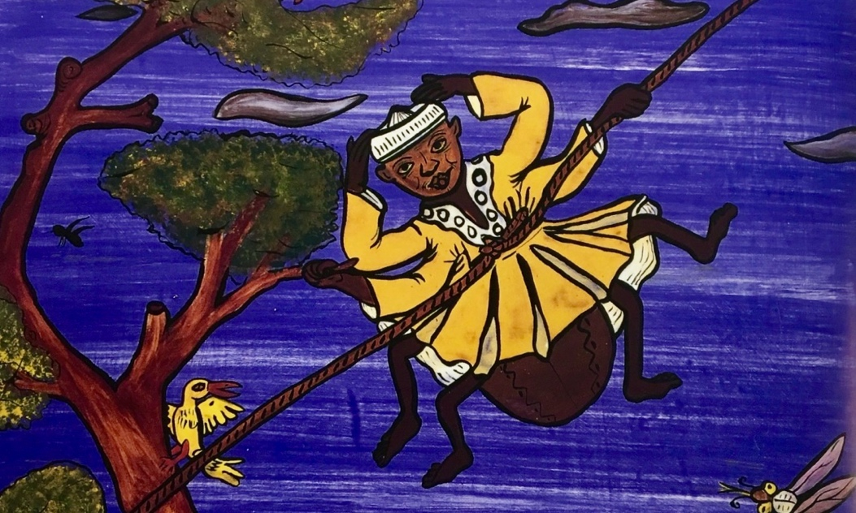

Part 1 Questions

- What food had Ananse dreamt about?
- What was the name of the city he came to?
- What did he hope for when he arrived in the city?
- What did Ananse think he had smelt?
- What food had been prepared for him?
- Why did Ananse pretend to faint?
- What lie did he tell?
- What problem did this leave Ananse?
- What did Ananse have to go and eat?
Story Summary and Predictions
Use the first three boxes to tell the story so far. Use the bottom three boxes to show what you think might happen.
1 | 2 | 3
4 | 5 | 6

Part 1 Questions – Possible Answers

- What food had Ananse dreamt about?
Ananse had dreamt about eating rice and spinach sauce and crab and palm-nut soup.
- What was the name of the city he came to?
The name of the city was Po-Ano.
- What did he hope for now that he arrived in the city?
Ananse hoped he would be well fed in this city. He was the king’s guest.
- What did Ananse think he had smelt?
Ananse thought that he smelt rice and chicken stew.
- What food had been prepared for him?
The servants had prepared cassava.
- Why did Ananse pretend to faint?
Ananse pretended to faint because he hated cassava and did not want to eat it.
- What lie did he tell?
Ananse lied and said that he was allergic to cassava.
- What problem did this leave Ananse?
The problem that this left Ananse was that cassava was the only thing eaten in this kingdom.

- What did Ananse have to go and eat?
Ananse had to go and eat leaves and bugs

