What to do today
IMPORTANT Parent or Carer – Read this page with your child and check that you are happy with what they have to do and any weblinks or use of internet.

1. Write descriptions of a thunderstorm
- Look at the picture: Thunderstorm
- Can you imagine being in a storm like that? Write some descriptions of what you would see, here and feel.

2. Read a poem
- Read Thunder and Lightning
- Underline the verbs that have been used in the poem. Can you highlight any other powerful language that has been used in the poem?
- Practise reading the poem out loud until you read with real expression.

3. Answer questions about a poem
- Read That Stormy Night.
- Answer Stormy Night Questions. Write your answers in clear sentences.
- Share your answers with a grown-up. You can check some of them at the end of this pack.

4. Make a choice.
- Read Where Would You Be?
- Decide where you would want to be – inside or out in the wild. Write 3-5 sentences to explain your choice.

Try the Fun-Time Extras
- Pick your favourite of the three poems:
- Can you make an illustration for it?
- Can you learn all or some of it off-by-heart?
- Can you record and share your reading of the poem?
- Can you write your own poem about a storm?

Thunderstorm

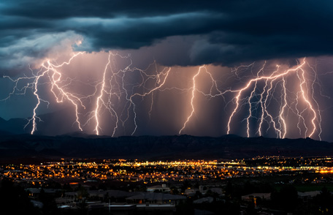

Thunder and Lightning

Blood punches through every vein
As lightning strips the windowpane

Under its flashing whip, a white
Village leaps to light.

On tubs of thunder, fists of rain
Slog it out of sight again.

Blood punches the heart with fright
As rain belts the village night.

by James Kirkup

That Stormy Night

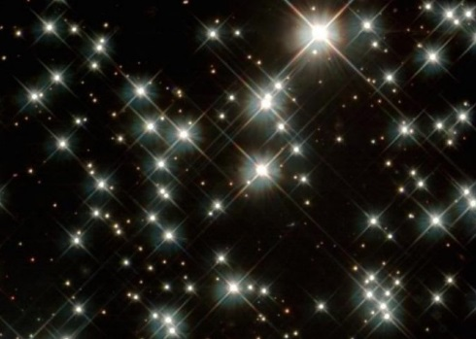

That stormy night
when the wind moaned like a wolf
and bent the trees, and shook the house
I wondered if it could blow the stars away.

What then – if their glittering dust
lay among the fallen leaves the next day
crystals and splinters in the morning light?
I’d sweep them up and put them in a box

and bring them home to you. You’d say
Nonsense. What you see up there
is light that’s millions of years away
you know that, don’t you?

Yes. I know. But still
I’d shake my box of stardust
hold it tight
knowing the wind had blown the stars away

that stormy night
by Berlie Doherty

Stormy Night - Questions

- What simile does the poet use for the wind’s sound?
- What two effects does the wind have?
- What does the narrator wonder?
- What adjective is used to describe star dust?
- Who do you think the narrator takes the box to?
- Why don’t you think that they believe there is stardust in the box?
- What is your favourite phrase in this poem? Why?
- What is your opinion of this poem?

Where would you be?

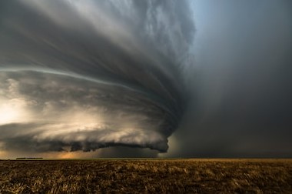

Where would you be on a night like this
With the wind so dark and howling?
Close to the light
Wrapped warm and tight
Or there where the cats are prowling?

Where would you wish you on such a night
When the twisting trees are tossed?
Safe in a chair
In the lamp-lit air
Or out where the moon is lost?

Where would you be when the white waves roar
On the tumbling storm-torn sea?
Tucked inside
Where it’s calm and dry
Or searching for stars in the furious sky
Whipped by the whine of the gale’s wild cry
Out in the night with me?

by Karla Kuskin
Thunder and Lightning - answers

Blood punches through every vein
As lightning strips the windowpane
Verbs underlined
Powerful language highlighted

Under its flashing whip, a white
Village leaps to light.

On tubs of thunder, fists of rain
Slog it out of sight again.

Blood punches the heart with fright
As rain belts the village night.

Stormy Night - Answers

- What simile does the poet use for the wind’s sound?
The simile used is ‘moaned like a wolf’.
- What two effects does the wind have?
The wind bends the trees and shakes the houses.
- What does the narrator wonder?
The narrator wonders whether the wind could blow the stars away.
- What adjective is used to describe star dust?
The adjective used is the word, ‘glittering’.

