What to do today
IMPORTANT Parent or Carer – Read this page with your child and check that you are happy with what they have to do and any weblinks or use of internet.

1. Read two sets of opinions
- Read Zoo Opinion 1.
- Which of the writer’s points do you think is most powerful? Why?
- Read Zoo Opinion 2.
- Which of these two pieces of writing do you agree with most? Why?

2. Practise using adverbials
- Use the Revision Card to remind yourself about adverbials.
- Complete Adverbials in Sentences. Find and underline the adverbials.

3. Now for some writing
- Write a letter to a zoo-owner, asking them to treat the animals well.
- Explain why they should do this and how they can do this.
- Plan your letter on the Skeleton Frame and then write it out carefully.

Well done! Share your writing with a grown-up. Show them the adverbials that you have used. You can check your answers to the Adverbials in Sentences at the end of this pack.

Try the Fun-Time Extra
- Can you research more about zoos? You could use these sites:
www.bbc.co.uk/guides/ztkpn39#zs6c4wx
www.nationalgeographic.org/encyclopedia/zoo/
www.batterseaparkzoo.co.uk
www.zsl.org/kids-zsl
www.chesterzoo.org/explore-the-zoo
Zoo Opinion 1

The problem with zoos is that lots of them soothe their feelings of guilt by telling themselves that they are really doing these animals a favour by contributing towards the conservation of the species. The reality, however, is very different. Many of these animals that are bred in captivity never get to experience their true identity. They never get to roam around freely, making relationships and acting in a natural way. They are told what to eat, when to sleep, what to play with (if anything!) and how to act. They will never be released as they wouldn’t be able to survive for more than five minutes in the wild. So, the next time you see an animal in the zoo, please consider these points and DON’T be fooled by the signs telling you the zoo is keeping the animal contained for the better good because this is definitely not the case!

Some might say that zoos help the animal have a longer life BUT does longer necessarily mean BETTER? Ok, so the animal might have another few years on this planet, but you have to ask yourself: does it really want those extra years? Wouldn’t it be better to put it out of its misery sooner? In the wild, animals live life to the full every day, and, whilst I accept that this may mean they are subject to an early death by predators or disease, this still has to be better than sitting in a tiny cage having humans shout at you and having cameras flash at you all day, every day, doesn’t it?

Zoo Opinion 2

Can everyone afford a trip to Africa or the Arctic? I don’t think so. This is where zoos come into their own. Instead of having to pay thousands on flights and travel, the cost of the zoo is nothing AND you are at least guaranteed to see some animals. There have been stories where people have paid extraordinary amounts of money to go on safari and they haven’t even seen a bird! What a waste of money and time! Isn’t it better to have these animals in zoos around the county so they are accessible to everyone and not just the elite who can afford it?

If someone has never seen a tiger in real-life, why would they bother donating money to save the tigers in the wild? However, once they have seen the beauty and majestic qualities a tiger has, by visiting a zoo, then they will surely be much more likely to donate in the shop or when they get home. Therefore, that one tiger in the zoo has helped save thousands of others in their natural habitats.

Some endangered species in the wild find it almost impossible to find a mate as their species numbers are so small, making an already awful situation even worse. This is where zoos with a comprehensive conservation programme come into their own. Through these programmes, animals can be paired up with a suitable mate and they will go on to have strong babies that have a good chance of being released back into the wild. The animals remaining in the zoo lead a peaceful and contented life with a companion rather than having the gruelling struggle of trying the find a mate for their whole life.

Revision Card - Adverbials

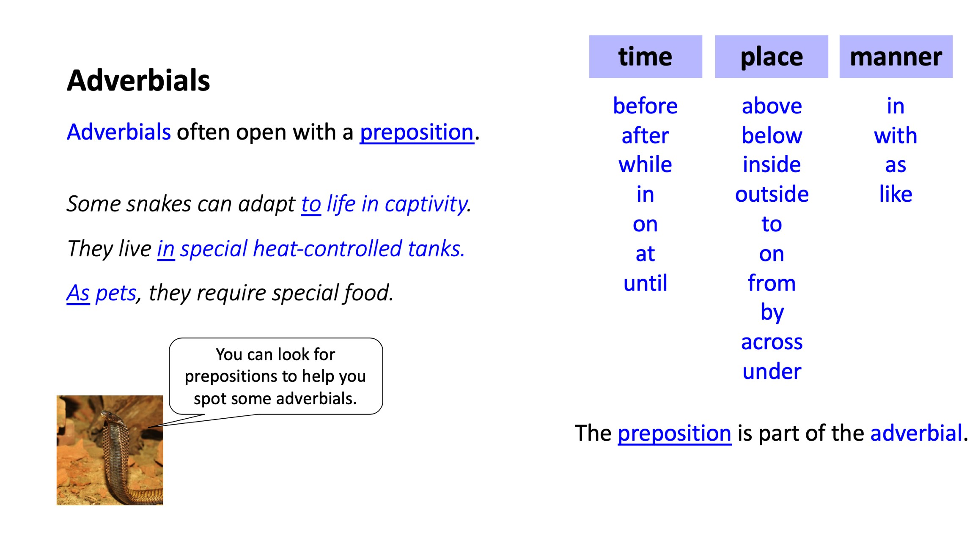

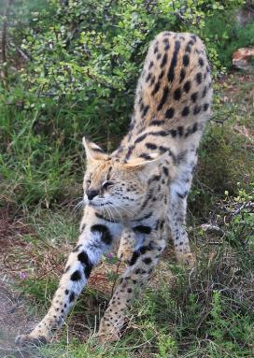
- Identify the adverbials in each sentence.
- Add commas to fronted adverbials.
- Discuss the main purpose of the article.
HINT: Look for the main clause and find the verb.
The adverbial will be modifying it.

Adverbials in sentences

- In the UK thousands of exotic animals are kept as pets.
- Usually people keep exotic animals for interest or kudos.
- Many species can be kept successfully in captivity.
- Sadly studies have shown that other animals struggle away from their natural habitats.
- Snakes, lemurs and crocodiles are just some of the exotic pets privately kept across the UK.
- Often lemurs are challenging to keep in captivity.
- In the wild they have constant stimulation from foraging and socialising.
- Stressed or bored captive lemurs can become unhealthy after a while.
- Crocodiles are aggressive and hostile towards humans.
- With a powerful bite crocodiles make dangerous pets to have in a home.
- To make them safer venomous snakes are defanged sometimes.
- Few exotic animals can thrive in human homes.

Skeleton Frame
Title:_________________________________
Introduction (What? Who? Where? Why?)

- Point 1
- Point 2
- Point 3
- Point 4
Conclusion (Summarise what you have argued.)

Your Letter

Adverbials in Persuasive Writing: (answers)

- In the UK, thousands of exotic animals are kept as pets.
- Usually, people keep exotic animals for interest or kudos.
- Many species can be kept successfully in captivity.
- Sadly, studies have shown that other animals struggle away from their natural habitats.
- Snakes, lemurs and crocodiles are just some of the exotic pets privately kept across the UK.
- Often, lemurs are challenging to keep in captivity.
- In the wild, they have constant stimulation from foraging and socialising.
- Stressed or bored captive lemurs can become unhealthy after a while.
- Crocodiles are aggressive and hostile towards humans.
- With a powerful bite, crocodiles make dangerous pets to have in a home.
- To make them safer, venomous snakes are defanged sometimes.
- Few exotic animals can thrive in human homes.

