What to do today
IMPORTANT Parent or Carer – Read this page with your child and check that you are happy with what they have to do and any weblinks or use of internet.

1. Imagine how characters might react
- Read Messenger’s Proclamation.
- In the story this proclamation is read to Mufaro, Manyara and Nyasha. How do you think they will react? If you were in the story, how would you react?

2. Read the next part of the story
- Read Manyara’s Journey to find out what happened to her after she had heard the proclamation.
- Write down what you would have done, with each of the people that she met.

3. Listen to the whole story being read.
- Listen to this reading of the whole story.
https://www.youtube.com/watch?v=dP9cQkS8p2Q&t=24s
- Answer the Story Questions.

4. Think about the character of the King
- Write notes around The King. What do we know about him from the story? What do you think about him? Was he fair?

Try the Fun-Time Extras
Can you try telling the story of Mufaro’s Beautiful Daughters to somebody else?
Can you act out a scene from the story?

Messenger’s Proclamation

The most worthy and beautiful daughters in the land are invited to appear before the King, and he will choose one to become Queen!

Manyara’s Journey

Read about Manyara’s journey and decide what you would do.

That night when everyone was asleep, Manyara stole quietly out of the village. She had never been in the forest at night before and she was frightened, but her greed to be the first to appear before the king drove her on. In her hurry, she almost stumbled over a small boy who suddenly appeared, standing in the path.

The boy told her he was hungry and asked her politely for something to eat.

1. What would you do? Why?

After travelling for what seemed to be a great distance, Manyara came to a small clearing. There, silhouetted against the moonlight was an old woman seated on a large stone.

The woman gave advice. She told Manyara that she would see laughing trees but must not laugh in return. She told her that she would meet a man with his head under his arm and that she must be polite to him.
2. What would you say? Why?

Manyara came to the grove of trees
and they did seem to laugh at her.

3. What would you do if the trees laughed
at you? Why?

Later Manyara saw the man with head tucked under his arm.

4. What would you do? Why?
Story Questions

- Were you surprised about how Manyara treated those she met? Why/Why Not?

- What did Manyara say about the monster that she saw?

- How do you think Nyasha felt as she went into the chamber?

- Why did Mufaro say that he was the happiest father in all the land, at the end of the story?

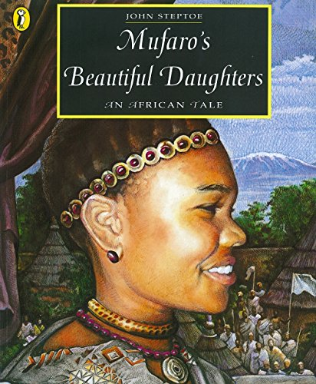

The King

