Send me your work or any questions at ccs@tda.education
¡Hola chicos y chicas!
Write the date in Spanish on your book:

Hoy es___________, _____de______________del 2020

Challange
From the following images, try to remeber as many as possible. You CAN´T use a dictionary.
You have just 1 minute

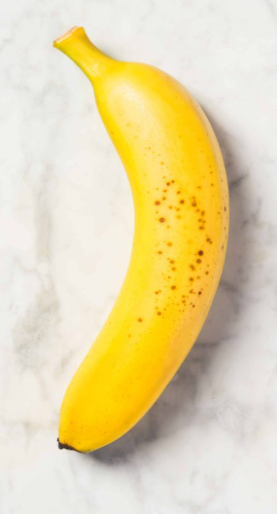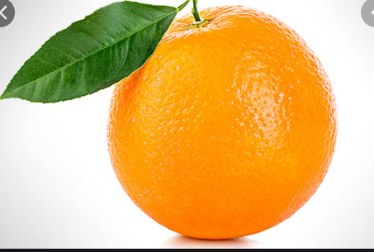

1.. 6..
2.. 7..
3.. 8..
4.. 9..
5.. 10..

¡Buena suerte! Good luck

