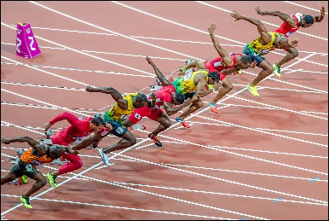
100M SPRINT

How it works:
Athletes race 100m down the home straight of a 400m track. They start in running blocks and run in lanes.
A reaction time is measured by sensors in the staring pistol and blocks, even if less than 0.1 second is detected it’s deemed a false start.

History:
The ‘Stade’ (192m race) was part of the Ancient Olympics. In more modern times, the 100-yard (91.44m race) was adopted as the foremost sprint. This was part of the commonwealth games until 1966. However, the classic 100m has been part of the Olympics since 1896.

Do you know?:
Sprinters typically reach their peak speed between 50-60m.
Usain Bolts record of 9.58sec for 100m equals an average speed of 23.35MPH.
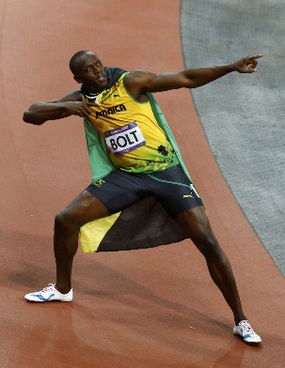
A domestic can run faster than Bolt.
Sprinters in lane 1 react faster to the starting gun.

World records:
Usain Bolt – 9.58 – 2009
Florence Griffith Joyner – 10.49 – 1988

Olympic records:
Usain Bolt – 9.63 – 2012
Florence Griffith Joyner – 10.62 – 1988

5 stages of 100m sprint:

1. Reaction time
The athlete is required to make a rapid physical response to the external stimulus of the starting pistol which allows a smooth clearance off the starting blocks. Reaction time is measured by the time taken between the introduction of the stimulus and the first muscular reaction or movement performed by the athlete.

2. Starting ability
The ability to push out from the starting-blocks cleanly and powerfully is crucial to success in the 100m. The athlete must adopt a mechanically sound starting position and generate great power in order to overcome inertial and frictional forces in the opening strides.

3. Acceleration
The athlete must accelerate from the starting blocks to maximum velocity in as short a time as possible. A low body position should be maintained in the first 20m, with most of the upper body above and forward of the centre of mass. There should be a sense of driving the track behind the body as the athlete gradually rises to an upright posture. The athlete must then strive to increase velocity over as great a distance as they are able to.

4. Maintaining speed
Maintaining high horizontal speed (speed endurance) can be achieved through good striding technique, which allows an equal emphasis on work performed behind and in front of the centre of mass (e.g. ‘high knees in front, full leg extension behind’). There is a feeling of bounce in the lower limbs as the athlete embarks on a brief period of flight in the recovery phase of each stride.

5. Overcoming deceleration
The athlete must stay relaxed but strive to resist an inevitable decline in velocity in the final stages of the sprint performance. There should be an emphasis on work performed ahead of the centre of mass (e.g. ‘high knees, high hands in front’). The purpose here is to lighten and reduce the duration of foot-strike in order to sustain the rate of cadence in the tiring legs.
Usain Bolt - https://www.youtube.com/watch?v=bVTqySCtzVI
Florence Griffith Joyner - https://www.youtube.com/watch?v=Mrt9yZL8dbI

Question time:
At what distance do sprinters reach their peak speed?
What is Usain Bolts world record?
How many phases are there to the sprint technique?
Which female holds the Olympic record?
What is the lowest timing that’s still deemed as a false start?

