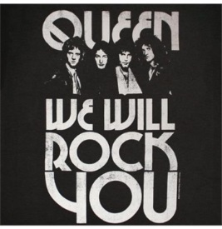
Listening to “We Will Rock You” - Queen

Watch the short You tube clip to remind you what the structure of a typical song is: https://youtu.be/oXifpcE7ewU

Now Listen to the opening of “We Will Rock You” by Queen which is based on a Riff and Hook https://www.youtube.com/watch?v=-tJYN-eG1zk. As you listen to the lyrics of the song, find the missing words and complete the lyrics, choosing from those given in the box below. Then identify the song structure by writing either the word VERSE or CHORUS in the boxes.

Buddy you’re a make a big noise.
Playin’ in the gonna be a big man some day.
You got mud on yo’ ,
You disgrace,
Kickin’ your can all over the .

We will, we will, rock you.
We will, we will, rock you.

Buddy you’re a man hard man.
Shoutin’ in the street gonna take on the world some day.
You got blood on yo’ face,
You big disgrace,
Wavin’ your all over the place.

We will, we will, rock you.
We will, we will, rock you.

Buddy you’re a man poor man.
Pleadin’ with your gonna make you some peace some day.
You got mud on your face,
You big disgrace,
better put you back in your place.

We will, we will, rock you.
We will, we will, rock you.
Music Key Words Crossword
Complete the following crossword which contains the key words from your music learning. Use the internet to help you answer the questions below.
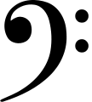
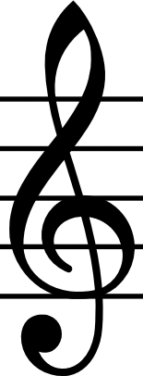
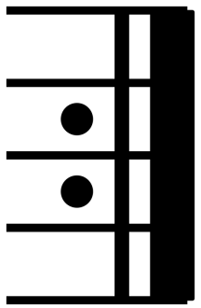
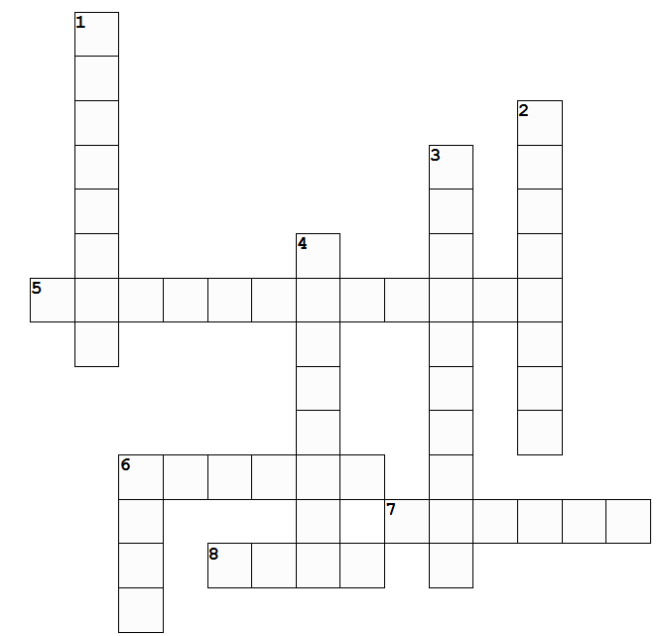
3..
1.
5.
Across Clues
5. The musical symbol made up of two dots and a double bar-line (shown above) (6,6)
6. The musical word for playing or performing something again (6)
7. The 'main tune' of a song or piece of music. (6)
8. The 'catchy bit' of a song or piece of music that you will remember, often short and can be verbal, rhythmic or melodic. (4)
Down Clues
1. A musical symbol showing that notes are to be performed at low pitch (shown above). (4,4)
2. The lowest pitched part of the music, often played by low-pitch instruments. (4,4)
3. A musical symbol showing that notes are to be performed at high pitch (shown above). (6,4)
4. A word used in 'Classical' music to describe a repeated musical pattern. (8)
6. A repeated musical pattern used in popular music and songs. (4)

