Britain’s Temperatures
winter sun summer cold equator Atlantic
north east south west Atlantic ocean

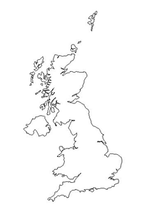
Summer Temperatures Winter Temperatures
4OC
6OC
16OC
14OC
In the ________________in the UK the weather is warmest in the _________ of the country and coldest in the _________ of the country. This is because the west of the UK is closer to the ___________ ________, which is a warm sea, because of a current called the North ___________ Drift. The east is cold because the North Sea is a ________ sea.
In the ________________in the UK the weather is hottest in the _________ of the country and coolest in the _________ of the country. This is because the south of the UK is closer to the ___________, which is the warmest place on Earth. This is because the _____’s rays are focused on the Equator all _______ round.

