Storm Desmond: Homes flooded and thousands left without power

Tens of thousands of homes have been left without power after Storm Desmond caused severe flooding across northern England and parts of Scotland. The Army is helping to evacuate people in Cumbria and the Scottish Borders, as scores of severe flood warnings remain. Some 55,000 properties are without power after flooding at a substation in Lancaster, while a second substation in Carlisle is also under threat.

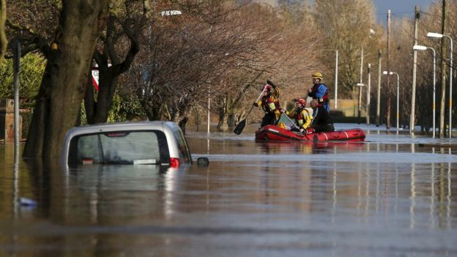
Rescue workers attempt to reach local residents in Carlisle
Provisional figures suggest more than 340mm of rain fell in 24 hours in the Lake District - which would be a new British record if verified, the Environment Agency said. The Met Office has issued fresh yellow warnings for rain next week for areas already affected.

BBC Weather's John Hammond, who is in Keswick, Cumbria, said: "It's totally dry here now and will generally remain so for the rest of the day, but we are concerned about further rainfall through this week. There is more heavy rain in the forecast for flood-affected areas in the next few days and river levels downstream could be adversely affected. We'll particularly be watching the Rivers Ouse and Severn closely."

In Cumbria, where a major incident was declared, emergency crews are using boats to carry people to safety and eight rescue centres have been opened for those forced to leave their homes.

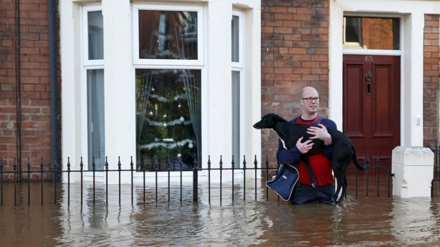
At the scene

A man holds his dog as he wades through a flooded road in Carlisle

BBC north of England correspondent Danny Savage
Coastguards and lifeboats are in the centre of Carlisle. This city has seen it all before but it doesn't make it any easier. I left Warwick Road about 01:00 GMT this morning with water rising rapidly. By 09:00 it had spread much further towards the city - this appears to be worse than 2005. The Army is here to help after the police went wading door to door in the early hours making sure residents were at least safe. Later, rescue teams with boats arrived to move those people who did want to leave.
They had watched the modern flood defences anxiously for hours. At 22:00 last night they were telling us the water was up to the top of the flood barriers and at about midnight it came spilling over.

Thousands of properties are without electricity - a hospital in Lancaster is running on generator power and there are worries about a substation in Carlisle. Residents are being told to keep phones fully charged now - if that substation goes, sixty thousand properties could be left without power.

Defences 'did work'
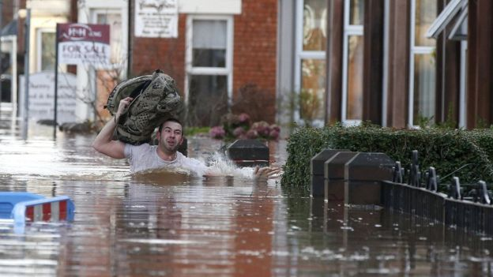
In 2010, a £38m flood defence scheme for Carlisle - which has seen some of the worst flooding - was completed in a bid to protect about 3,000 homes and businesses around the city.
Floods minister Rory Stewart said defences - which have been criticised - had given authorities more time to evacuate people and kept flood levels down. Defences had been overtopped following "unprecedented" levels of rain, he added.

Mayor of Keswick Paul Titley agreed the defences had been "completely overwhelmed. The flood defences were designed for a one in 100-year event and since it's six years since we had the last one, we were sort of surprised that we got one so soon," he added.
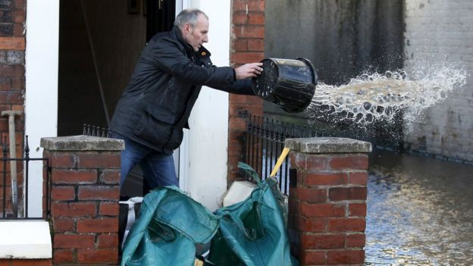
Residents have also had to bale out water from their properties. Around 150 people were rescued overnight by the coastguard after a static residential caravan park was heavily
flooded at Eamont Bridge near Penrith.

In Scotland, 600 people were evacuated from their homes in the borders town of Hawick and a train headed for Glasgow was left stranded at Carlisle station with passengers having to sleep on board overnight.

Storm Desmond is the fourth storm to be given a name by the public in a project by the Met Office and Met Eireann in Ireland to help raise awareness of severe weather.

http://www.bbc.co.uk/news/uk-35019021

