 | To achieve a pass the learner must evidence that they can: | In addition to the pass criteria, to achieve a merit the evidence must show the learner can: | In addition to fulfilling the pass and merit criteria, to achieve a distinction the evidence must show that the learner can: | Comments
PO1 : Identify customer requirements | P1: Describe the end user of the item being designed. |  |  | 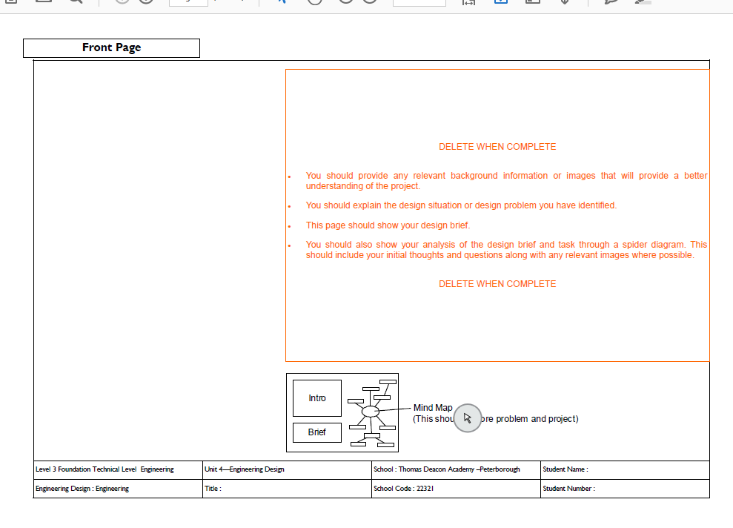
 | P2 : Produce a CDB to explore design problems, requirements and design constraints for a specific customer need. | M1 : Explore additional  Stakeholder requirements that may influence the CDB. |  | 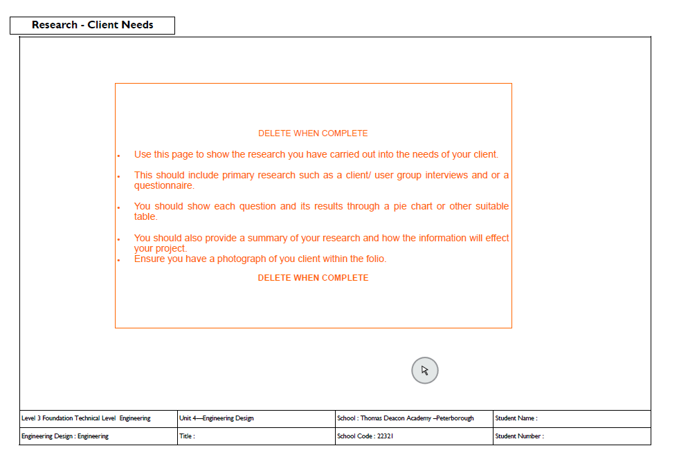
 | P3 : Produce a PDS that addresses a design problem that covers all of the key requirements using relevant terminology that demonstrates consideration of technical feasibility and costs. | M2 : Analyse similar products and possible manufacturing processes to inform the design specification. |  | 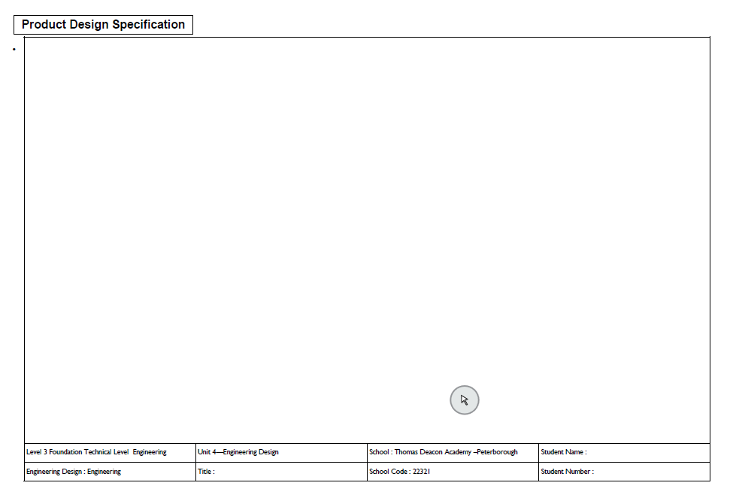
PO2 : Initial ideas and  concept generation | P4 : Produce three concepts  that address the design problem and meet a design brief, supported  by high quality sketches and relevant technical information.
P5 : Identify relevant
health and safety, environmental
and legislative considerations for the design
 | P6 : Produce a SWOT analysis of initial ideas to solve an engineering  design problem. | M3 : Select and justify the  final design concept.
 | P7 : Identify final technical  information required for the design (eg physical dimensions, materials,  processes etc). | M4 : Analyse technical and aesthetic design considerations to inform product design. | D1 : Assess design proposal for further development and modification for mass or batch  production.
PO3  Produce detailed  engineering designs | P8 : Produce a CAD drawing  that meets all elements of the CDB and PDS and complies with all  relevant regulations, standards directives or codes of practice. | M5 : Justify the selection  of manufacturing processes and  the choice of the components and  materials used for the design. | D2 : Design demonstrates  mechanical functionality  and integration of electrical components.  Circuit Requirements
P9 : Present design using
appropriate techniques to different audiences with sufficient information to allow the customer(s) to assess it.

P10 : Produce and maintain
design documentation.
Contents Page
PO4  Manage engineering  designs | P11 : Produce a test plan that  reflects all aspects of the design, highlighting where the design  problem has been solved.  Evaluation | M6 : Identify design adjustments to reflect testing and potential for  modification for mass or batch production  Further Development – Refining so it is easy to make | D3 : Evaluate the importance  of testing in engineering design.
P12 : Carry out relevant design tests.

Sustainability Report
P13 : Produce a technical
report including an evaluation of the end to end design and
problem-solving process.
Complete
Monday, 1

Peer Review : 1st April 2020
Hand in : 3RD April

