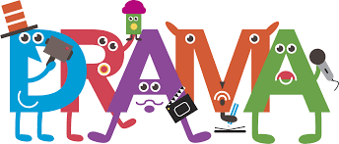

Drama Skills
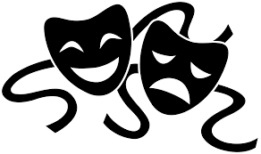

Name: _______________________________________________
Class: _______________________________________________
Teacher: _______________________________________________

Understanding Key Terms
Provide a definition for each of the Drama Techniques identified below:

- Tableau
_____________________________________________________________________________________________ [1]

- Slow Motion
_____________________________________________________________________________________________ [1]

- Soliloquy
_____________________________________________________________________________________________ [1]

- Freeze Frame
_____________________________________________________________________________________________ [1]

- Still Image
_____________________________________________________________________________________________ [1]

- Monologue
_____________________________________________________________________________________________ [1]

- Flashback
_____________________________________________________________________________________________ [1]

- Flash forward
_____________________________________________________________________________________________ [1]

- Narration
_____________________________________________________________________________________________ [1]

- Movement
_____________________________________________________________________________________________ [1]

- Mime
_____________________________________________________________________________________________ [1]

- Soundscape
_____________________________________________________________________________________________ [1]

Understanding Stage Space

Research the different stage spaces and add images or draw what each stage space looks like.

- End On Stage

- Theatre in the Round

- Thrust

- Proscenium Arch

- Avenue

- Promenade

Using the stage areas identified in the box, mark the stage below with the correct terms (birds eye view)

Cyclorama
Audience

Word search – Conventions (Techniques)

Word search – Form & Structure

Word search – Language & Voice

Script
Read through the script below,

Script – Mood Board
Create a mood board (collection of 15-20 pictures) that sums up the scene you have read. They could be of the location, themes, characters, feelings…

Script – Costume Design
Design a costume for each of the characters. Don’t forget to annotate your designs and give reasons for your ideas.

Script – Set Design
The script is not set in a particular location. Decide where the scene would take place and design the stage set below.

Script – Sound Design
You need to add sound to your performance to make it come to life for the audience. Create a mind map of the different sounds you would use and justify them below.

Extension Task 1
Many books are turned into plays (films, tv etc.), these are called adaptations. Have a go at creating your own adaptation of your favourite book into a full-scale production.
You will need to create the following designs for your production:
1. Create a set design for your book. This could be a bird’s eye view; a 3D drawing from the audience’s perspective; a series of sketches of the stage layout and the backdrops; or a computer generated collection of pictures to illustrate your ideas. You could even create a live 3D version in miniature—the choice is yours. You should annotate your work, explaining your decisions.
2. Create a costume design for one of the key characters. This could be sketches, computer images, a collage including swatches of fabric; or you could photograph yourself or a family member in the sort of costume you would use. You should annotate your images with suggestions of what colours might suggest or represent, and with any further design notes you want to make that explain your decisions.
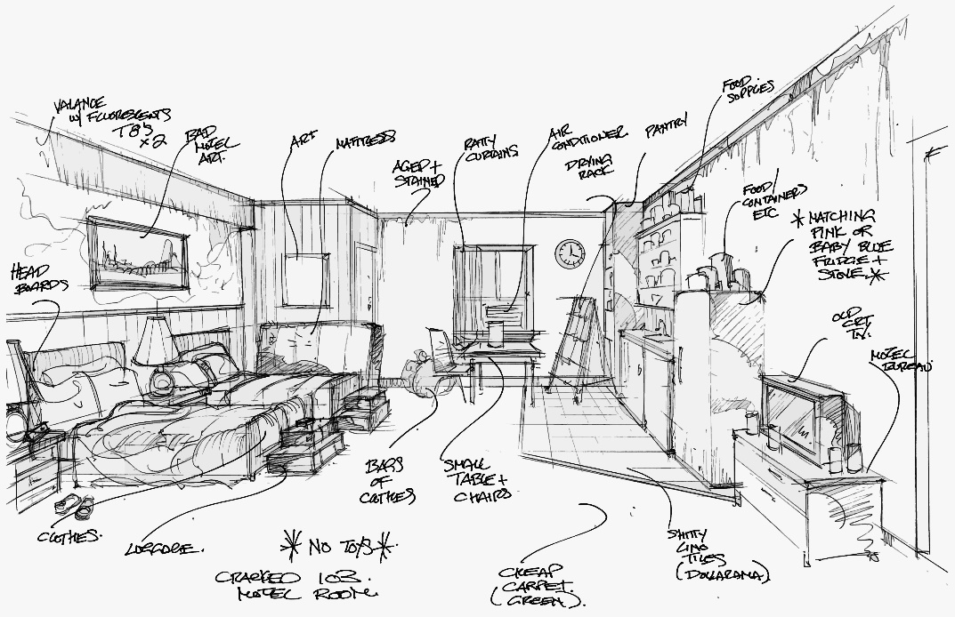
3. Create a poster to promote your performance. This might include sketches, computer images, text and background to your performance ideas. You may wish to look at some existing programmes or posters online to help develop your ideas. You should include annotations to explain your ideas.
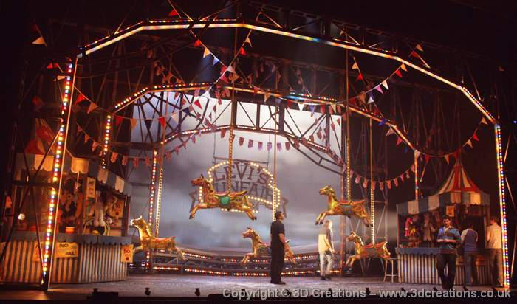

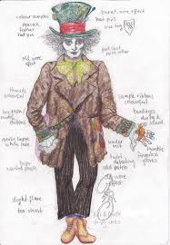
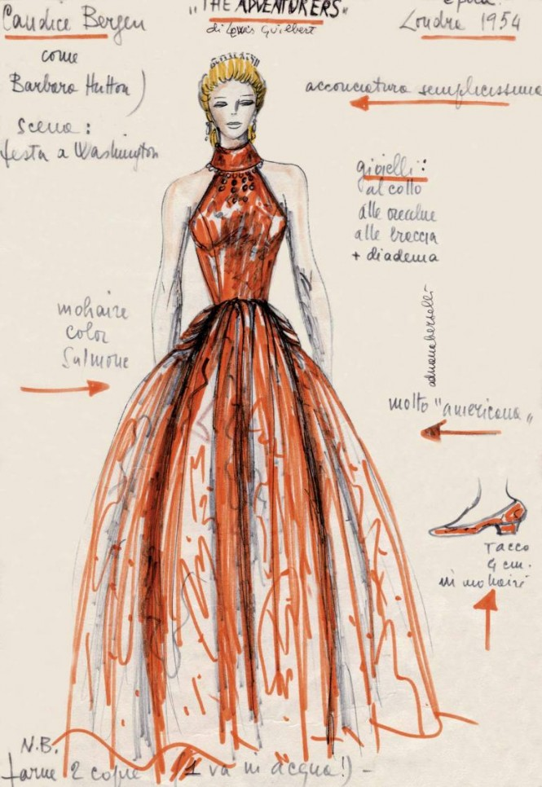

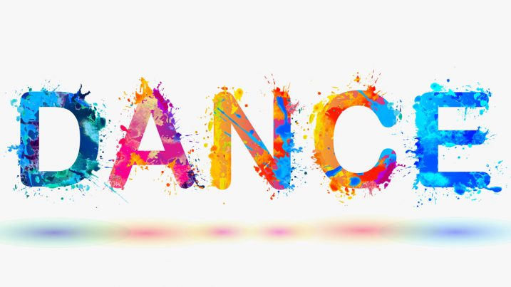

Dance Skills

Understanding Key Terms
In your own words, using full sentences, explain what each dance term means.
Can you find an image/picture that shows the word in action? You can copy and paste them onto this document.

Unison:
……………………………………………………………………………………………………………………………………………………………………………………………………
Canon:
……………………………………………………………………………………………………………………………………………………………………………………………………
Dynamics:
……………………………………………………………………………………………………………………………………………………………………………………………………
Formations:
……………………………………………………………………………………………………………………………………………………………………………………………………
Focus:
……………………………………………………………………………………………………………………………………………………………………………………………………

Warm Up Worksheet

1.Use the words in the box below to fill in the blank spaces.
Muscles, Mentally, Task, Heart

Warming up is the process of preparing the body for activity. The three main things a warm up should do are:

• Prepare the ________________and body for movement, increasing _____________ rate and breathing.

• Prepare ________________for dance activity.

• Offer a focus for the ______________ ahead.

2. Write down three things that you could do in a warm up:
 | Action | How its warming up the body?
1.
2.
3.
Our World
Compare and contrast the different styles of dance from across the world.
Style | Facts  e.g. Where did it begin, what sort of music do they use, key words, etc. | Movements  Draw and/or write
Indian Dance
Capoeira

Salsa

Breakdance

Flamenco

Think of your own. E.g. Irish

Performance Skills
There are two types of performance skills: technical and artistic.
Technical skills are the tools which help you perform the dance correctly and accurately, and the artistic skills help express the meaning or motivation behind the dance.
Here is a list of performance skills, re-write them under the correct heading, grouping them as either a technical or artistic performance skill: (The first 2 have been done for you)
Control Musicality Expression
Balance Projection Co-ordination Dynamics Flexibility Focus
Spatial awareness Posture Extension

Technical Skills | Artistic Skills
Co-ordination | Dynamics

