YEAR 9 DRAMA BOOKLET

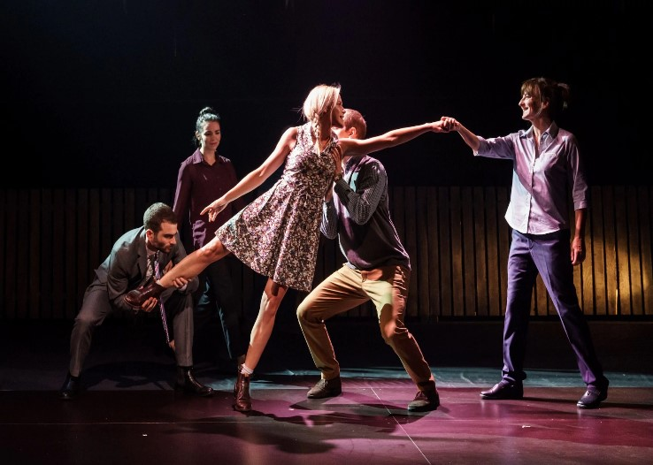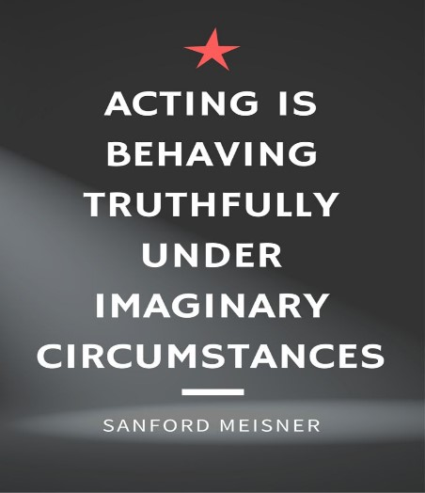

NAME ________
TEACHER ________

You are going to read the opening scene from a play called ‘Things I know to be true’. This is a play based around a family called the Price’s. The story is told through the four grown up children. Here is the list of the characters;
THE PRICE FAMILY
BOB, sixty-three, a retrenched auto factory worker
FRAN, Bob’s wife, fifty-seven, a senior nurse
THEIR CHILDREN
PIP, thirty-four, an education department bureaucrat
MARK, thirty-two, an IT specialist
BEN, twenty-eight, a financial services worker
and
ROSIE, nineteen, who doesn’t know who she is or what she wants to be yet

Setting
The play is set primarily in Hallett Cove, a working-class suburb, in Adelaide, Australia.
A family room, a kitchen and patio extension at the back open to a classic Australian backyard. A Hills Hoist, a lemon tree, a well-cut lawn, a rose garden, a shed up the back somewhere and an ancient eucalypt towering above.
The play takes place over a year.

Opening Scene - It Begins Like This
BOB PRICE stares at the telephone. His children are watching. The children are talking about their father.
PIP. It’s late.
BEN. Past midnight.
PIP. And the phone starts to ring.
MARK. You’re standing in your pyjamas and bare feet, still heavy with sleep because you’ve just been woken.
ROSIE. Your heart is beating.
BEN. Too fast.
ROSIE. Like it might go.
PIP. Any minute it might go.
ROSIE. And you know if you answer your life is going to change.
MARK. And you’re not ready for it.
PIP. Even though you’ve been waiting for this call ever since we were old enough to stay out past nine.
BEN. Ever since you stopped tucking us in at night and turning off the light.
ROSIE. Ever since we came screaming into this world.
PIP. You’ve been waiting for this.
MARK. And you’re thinking which one of my kids is in trouble?
ROSIE. Which one of my kids is hurt?
BEN. Which one of my kids is dead?
PIP. And how will I tell their mother?
BEN. You could turn around.
PIP. Walk away
ROSIE. Not answer.
MARK. But you know that this
BEN. Whatever this is
ROSIE. Just has to be faced.
The phone starts to ring… once… twice… three times… four times.
BOB answers.
BOB. Hello?
What do you think might be going on in this scene? What does the script suggest? What do you think is going to happen if the phone is answered? Imagine.

Q1 – Describe how you would design the SET for this section of the script? (Chairs, tables, carpets, include props like the telephone etc) Where would you set the play? Which room in the house? This will affect the look of the set. Then draw a picture of your set. Or you can create the picture on computer.

Describe the set.

Picture of Set design.

Q2 – Describe how you would design the LIGHTING for this section of the script? Remember the time of day it is set. (Think: Colour, Dark, Brightness, Spot Lights and Effects)
Describe the lighting.

Q3 – Describe how you would design the SOUND for this section of the script? (Think: Music or sound effects, like the phone ringing)
Describe the sound.

Q4 Describe how you would design the COSTUME for Bob in this section of the script? (Think: Style of clothes, age, colours, status, time of day/night) Then draw a picture of the costume design) Or you can create the picture on computer.

Describe Bob’s costume.

Picture of Bob’s costume design.

Physical Skills Worksheet
Complete the table below. Research the ones you don’t know online.
Term | Definition | Words you can use to describe  it:
Gesture |  | Eg. Clenched Fists
Posture |  | Eg. hunched…
Facial Expression |  | Eg. frowning…
Gait |  | Eg. stiff…
Eye Contact |  | Eg. intense…
Movement |  | Eg. smooth…
Proxemics |  | Eg. close…

Vocal Skills Worksheet
Complete the table below. Research the ones you don’t know online.
Term | Definition | Words you can use to describe  it:
Pitch |  | Eg. High...
Pace |  | Eg. fast…
Volume |  | Eg. shout…
Tone |  | Eg. nervous…
Accent |  | Eg. Scouse…
Pause |  | Eg. short…
Emphasis |  | Eg. brief…

In this question you are asked to explain how you would perform a certain line. You must DESCRIBE how you would do it and then
EXPLAIN why you would do it that way. To do this, you must refer to the vocal and physical skills you re-capped in the tables above.
Let’s have a go...
Q1. You are performing the role of Rosie. How would you use vocal and physical skills to perform the line “And you know if you answer, your whole life is going to change.”

Q2. You are now going to write the next scene. What to you think happens next? Write a script. You can keep the characters introduced in the play and you can add some more characters if you wish. You can also change location. Imagine.

.

