Year 7 Hinduism home learning project

Lesson 4: Karma and Samsara
Task 1: Watch the video and create a mind map of the key points. Then answer the following questions:
https://www.bbc.co.uk/programmes/p02n5v2q
- What does Karma have an effect on?
- Can you explain the cycle of life?
- Define reincarnation
- Draw your own circle of life diagram, showing key moments such as birth, learning to walk, going to school etc.

BBC bitesize: Lesson 1 and Lesson 2
https://www.bbc.co.uk/bitesize/topics/z2bw2hv/articles/zjdbpg8

Lesson 2: Puja
Task 1: Explain what is happening in this image

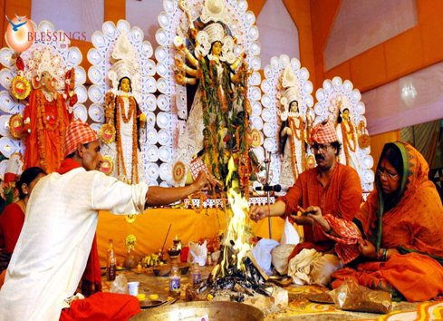

Task 2: Using BBC bitesize, answer the following questions:
- What is Hindu worship called?
- Where do Hindus pray?
- Do you think worship in the Mandir is more important than at home?

Task 3: Watch the following clip and make notes in a mind map.
https://www.bbc.co.uk/bitesize/clips/zh2hyrd

Lesson 5: Festivals- Diwali
Task 1: Answer the following questions:
- What is a festival?
- Why is it special?
Task 2: Diwali remembers the story of Rama and Sita. Watch the following video:
https://www.bbc.co.uk/programmes/p06ptdgh
- Summarise the story of Rama and Sita in no more than 10 bullet points.
- Explain why the story of Rama and Sita is important to Hindus.

Lesson 3: Inside a Mandir
Task 1: Watch the video and answer the following questions.
https://www.youtube.com/watch?v=jDc4CJscWws
- What do you think people gain from going to a mandir?
- In what ways does the architecture and layout of the mandir help people in the devotions?
Task 2: Design an information leaflet about a mandir.
Include:
- What is a mandir?
- What happens in a mandir?
- Why is important to Hindus?

Lesson1: One God or 33?
Task 1: Using BBC bitesize, answer the following questions:
- What is the name of the Hindu God?
- Why are there multiple forms of Gods and Goddesses?
Task 2: Watch the following clip and create a mind map on the importance of Hinduism
https://www.bbc.co.uk/programmes/p02n5wvr
Task 3: Using BBC bitesize, explain what is meant by the ‘Trimurti.

