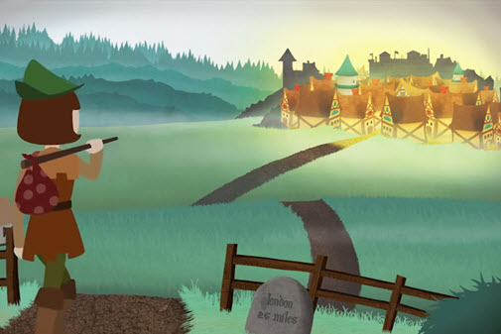
Story of Dick Whittington
EXPRESSIVE ARTS and MUSIC Project
Introduction: You will produce a project on the story of Dick Whittington, which you might have seen, as a pantomime. Each task contributes to Dick Whittington’s journey to London and what he might’ve seen and heard along the way. Remember this is a live theatre show. You will need to use your imagination!

Dick Whittington was a poor boy from Gloucestershire who walked to London to seek his fortune. He found work in the house of a rich merchant Fitzwarren, and fell in love with Fitzwarren's daughter, Alice. Dick had a cat to keep down the mice in the attic where he slept.

Number | Task | Instructions | Equipment needed
1 | Create a story board. | Read the story summary (above) and think about the beginning, middle and ending. You might want to research the story in more depth.  You must include;  Pictures of each section of the story.  At least 8 pictures detailing the story. | A4 paper  Pen
2 | Draw and label an instrument you might find in a live theatre band. | Choose an instrument to draw;  - Trumpet or Cornet.  - Trombone.  - Clarinet.  - Saxophone(s)  - Drums.  - Piano. | A4 paper  Pen  Pencil  Coloured pens
3 | Listen to two pieces of music;  ‘Take me back to London Town’.  ‘London Town’. | 1.https://www.youtube.com/watch?v=7t7pz4Ottvg  2.https://www.youtube.com/watch?v=5pvEOnnPjcw  - All instruments you can hear.  - Describe the tempo.  - Describe the dynamics. | Paper  Pen  Device
4 | Write a letter to Dick Whittington. | Write a letter to Dick Whittington giving him advice on what he should do once he gets to London. Where should he visit?  Who should he meet?  Example;  Dear Mr Whittington,  My name is _____ and I live in Peterborough. I have heard about your long and difficult journey you’ve walked from Gloucestershire to London. I think you might like to visit ___________. | A4 paper  Pen
5 | Create a set.  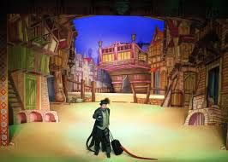 | Create a set (this includes houses and buildings) of London in around 1650. Roughly around the time when the play is set. If you have a phone - go onto google images and look up pictures of London around 1650. If not use the picture on the left to help you. You have a choice, you can draw it by hand or you could make a model of a set using any recycling you might have at home. | Pen, pencil, any unwanted recycling, glue or Sellotape.

